LAB 9.1

Scenario
In this lab you will perform advanced hacking techniques hunting at the endpoint level. Specifically, you will learn how to hunt for:
- AMSI bypasses
- Parent PID spoofing and
- Reflective DLL injection
- .Net malware

Goals
The learning objective of this lab is to increase familiarity with some commonly used and advanced hacking techniques.

What you will learn
You will learn how to utilize available alternative data sources and uncommon tools to detect the abovementioned attacks.

Recommended tools
- AmsiPatchDetection
- Custom Scripts
- memhunter
- Process Hacker 2
All the tools are present in C:\Users\Administrator\Desktop\Tools folder.

Tasks

Task 1. Hunt for AMSI bypasses
The Windows Antimalware Scan Interface (AMSI) is a versatile interface standard that allows your applications and services to integrate with any antimalware product that's present on a machine. While applications and services are running they can ask AMSI, "Is this line of code I'm about to run malicious?" AMSI is also an effective tool against certain obfuscation and evasion techniques, as it is queried immediately before each line is run, after any deobfuscation performed by the attacker.
This functionality is provided by amsi.dll. Thus, we can tell if a program potentially uses AMSI by the presence of this DLL in its loaded modules.
Let's take for example PowerShell. Any process has full permissions to modify its own internal memory space. As amsi.dll is loaded within the memory space of the PowerShell process, an attacker can use their PowerShell commands to attack AMSI itself.
Attackers start by finding the in memory location of the AMSI function, they introduce code that modifies the memory protections to be read, write, execute (you can verify this with Process Hacker 2) and finally, they re-write the AMSI function so that it always returns a negative ("this is not malware"). In other words, they are patching amsi.dll in memory.
Execute the provided AMSI bypass code and try to hunt for the changes it makes.
The AMSI bypass code (ASBBypass.ps1) is located in the Downloads directory.
Hint: The answer lies deep within Windows' memory management mechanics. It is not uncommon to see two (or more) processes using the same DLL (a good example is ntdll.dll). For optimization purposes, Windows doesn't load such a DLL multiple times. Windows load it once and each process refers to the memory location where the DLL was loaded. Does this mean that if code (DLL) is edited at runtime, all processes that refer to the same shared memory location will be affected as well? Luckily no! Before Image memory (DLL, EXE, etc.) is edited, Windows takes a copy of this chunk of memory, and makes it private to the process doing the editing. This is known as "Copy on Write" memory.
The real hint here is that Windows provides some system calls, allowing us to ask, for a given memory address in a given process, "Is this memory shared?" - or effectively, "Is it copy-on-write?" If we find the location of the amsi.dll in memory, and find that it is non-shared memory, this is a strong indication that this memory has been modified in the past, indicating that an AMSI bypass has been run.
A tool that performs the check above can be found below.

Task 2. Hunt for Parent PID Spoofing
Blue team members heavily utilize anomalies parent-child process relationships in order to uncover evil in their environments. Advanced adversaries can bypass this using Parent PID (PPID) Spoofing that allows for the execution of a malicious process from an arbitrary parent process.
For more information refer to the links below:
- https://blog.didierstevens.com/2017/03/20/
- https://blog.didierstevens.com/2009/11/22/quickpost-selectmyparent-or-playing-with-the-windows-process-tree/
- https://blog.cobaltstrike.com/2017/05/23/cobalt-strike-3-8-whos-your-daddy/
There are multiple ways to spoof a parent of a process. We will focus on the most commonly used one that involves the API call CreateProcessA. This function features a parameter called "lpStartupInfo" where one can specify the parent process he/she wants to use. To be more technically accurate, the lpStartupInfo parameter is a pointer to a STARTUPINFOEX structure. This structure contains an attribute list (lpAttributeList) and using UpdateProcThreadAttribute you can set the process parent via the "PROC_THREAD_ATTRIBUTE_PARENT_PROCESS" attribute.
One of the best forensic data sources in Windows is Event Tracing for Windows (ETW). ETW provides a real-time stream of data about events occurring on a system. Utilize ETW in order to hunt for PPID Spoofing.
You can emulate PPID Spoofing using a PowerShell script (PPID-Spoof.ps1) that resides at C:\Users\Administrator\Desktop\Tools\ppid-spoofing
Hint: For our detection purposes, the Microsoft-Windows-Kernel-Process provider can give us valuable insight into process creation. Specifically, the ProcessID value of the event header should match the ParentProcessID value. Be aware that legitimate spoofing may take place.
A script that can help you hunt for PPID Spoofing can be found at the C:\Users\Administrator\Desktop\Tools\ppid-spoofing directory.

SOLUTIONS
Below, you can find solutions for each task. Remember though, that you can follow your own strategy, which may be different from the one explained in the following lab.

Task 1. Hunt for AMSI bypasses
To hunt for the AMSI bypass using the provided code (ASBBypass.ps1), execute the following.
- Execute cmd.exe as an administrator
- Execute the AMSI bypass detection executable located at C:\Users\Administrator\Desktop\Tools\AmsiPatchDetection\AmsiPatchDetection\bin\Debug
You should see something similar to the below.
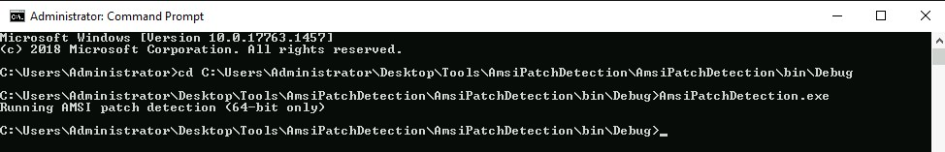
- Execute powershell.exe and execute the detection executable once again. You should something similar to the below (PowerShell uses AMSI).
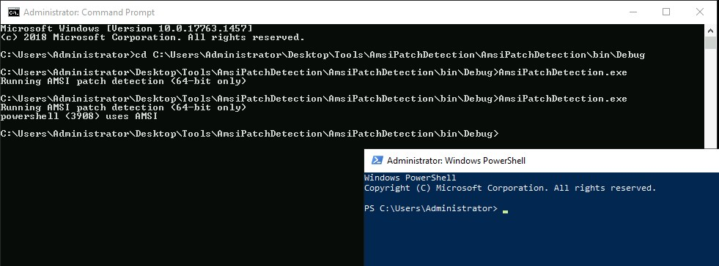
- Emulate the AMSI bypass code (ASBBypass.ps1) located in the Downloads directory, by executing the below inside the PowerShell terminal you previously spawned.
powershell -ep bypass
cd C:\Users\Administrator\Desktop\Tools\AmsiPatchDetection
.\ASBBypass.ps1
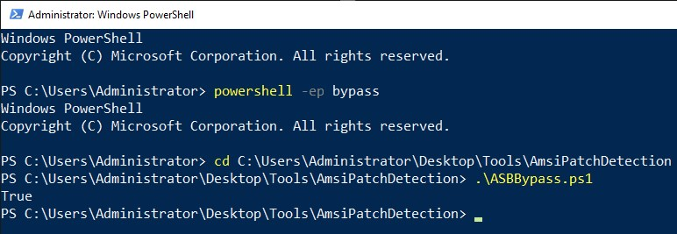
- Finally, execute the AMSI bypass detection executable again. You should now see it detecting the AMSI bypass on the PowerShell process.
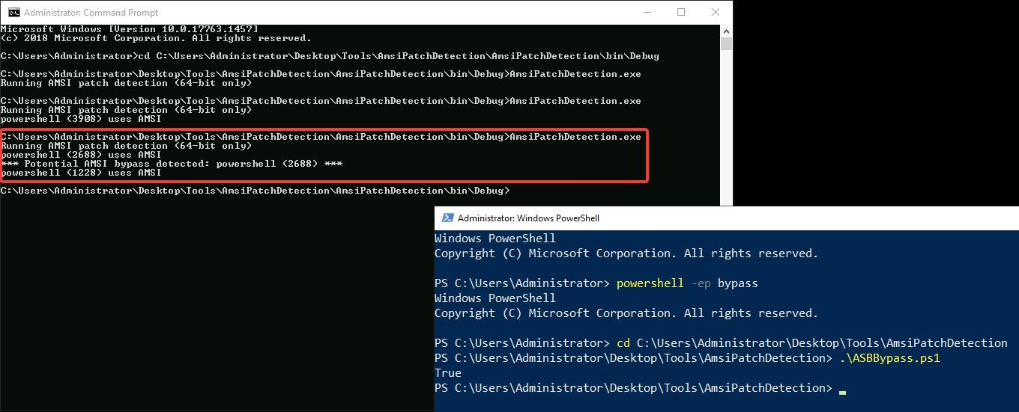
If you start Process Hacker 2 as an administrator, you will also be able to see the memory location of amsi.dll having read, write and execute rights (this is not a default behavior, it was caused by the AMSI bypass code).
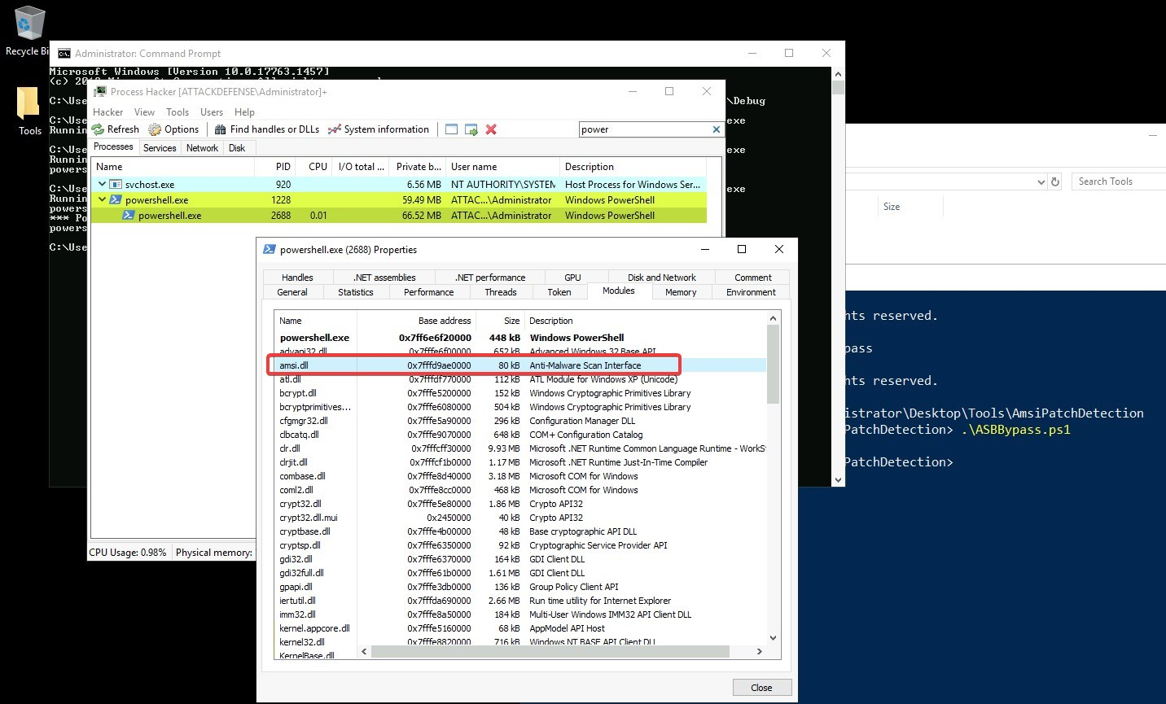

Task 2. Hunt for Parent PID Spoofing
To hunt for PPID Spoofing using the provided code (PPID-Spoof.ps1), execute the following.
- Execute cmd.exe as an administrator
- Execute the PPID Spoofing detection script (detect-ppid-spoof.py) located at C:\Users\Administrator\Desktop\Tools\ppid-spoofing
You should see something similar to the below.
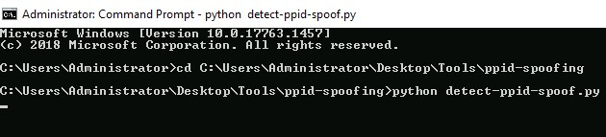
- Emulate the attack as follows.
  - Use the task manager and note explorer.exe's PID)
  - Execute powershell.exe as an administrator and then, execute the below
powershell -ep bypass
cd C:\Users\Administrator\Desktop\Tools\ppid-spoofing
import-module .\PPID-Spoof.ps1
PPID-Spoof -ppid 4752 -spawnTo "C:\Windows\System32\notepad.exe" -dllpath C:\Users\Administrator\Desktop\Tools\memhunter\msimplepayload.dll
You should see the below.
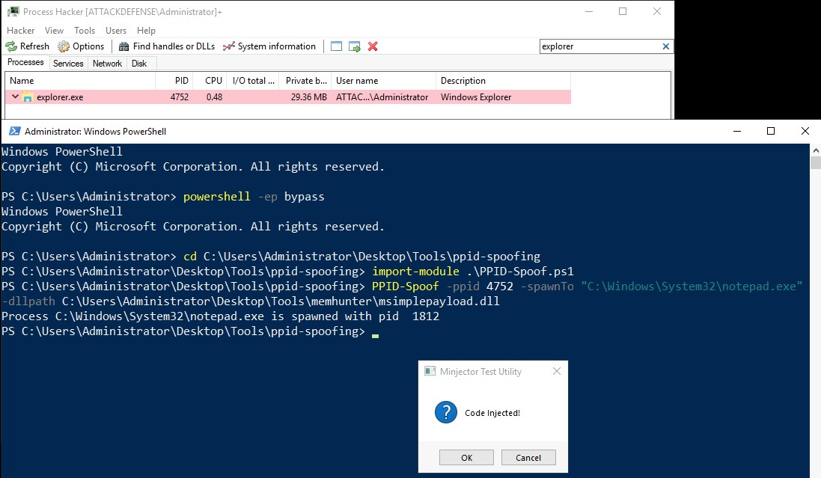
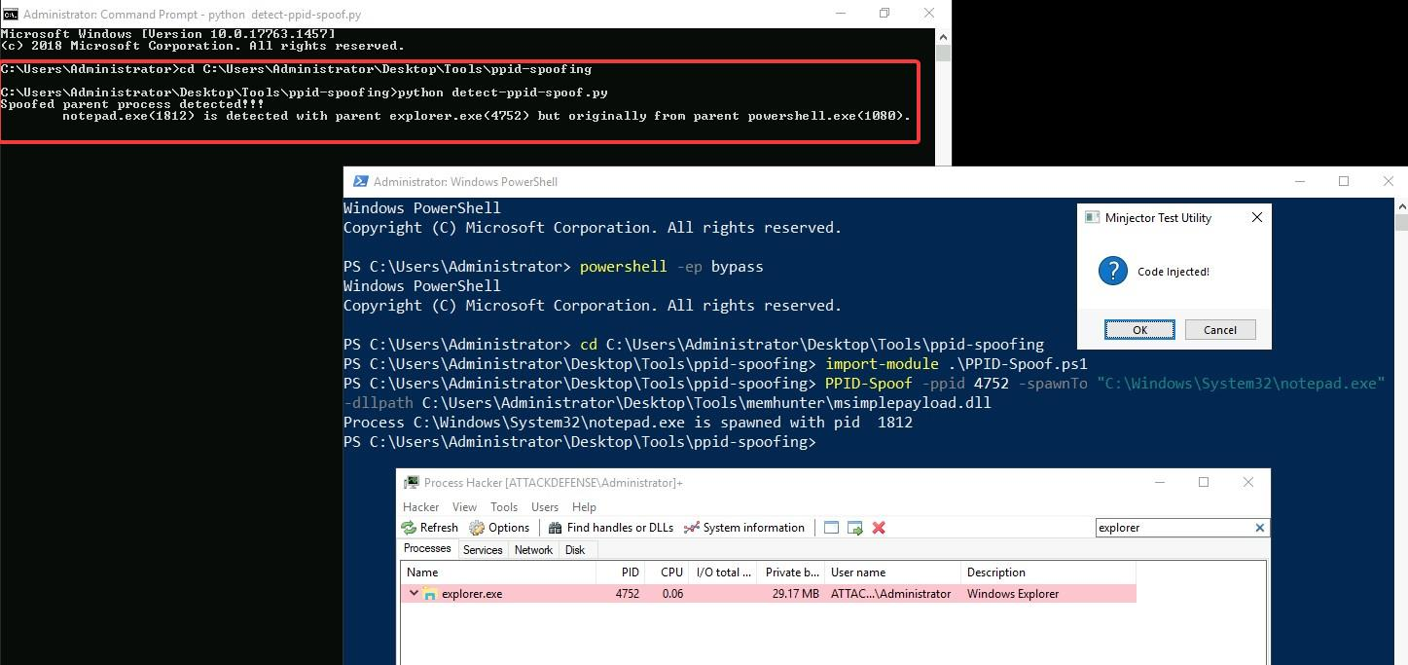
The detection script successfully identified the PPID spoofing activity.

References
- https://ionize.com.au/detecting-amsi-bypass/
- https://blog.f-secure.com/detecting-parent-pid-spoofing/

